 | Bioprocessing and Biomass Technology  Journal homepage: https://bioprocessing.utm.my | 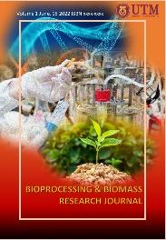

Research Article

Title of Article Title of Article Title of Article Title of Article Title of Article Title of Article

First A. Authorª, Second B. Author^{b}, Third C. Author^{c,*}

ª Faculty of Chemical Engineering, Universiti Teknologi Malaysia, Johor, Malaysia
^{b} Faculty of Chemical Engineering, Universiti Teknologi Malaysia, Johor, Malaysia
^{c} Faculty of Chemical Engineering, Universiti Teknologi Malaysia, Johor, Malaysia
ARTICLE INFO |  | ABSTRACT
Article History:  Received 01 March 2022  Received in revised form 12 March 2022  Accepted 15 March 2022  Available online 16 March 2022 |  | This document is a template for Bioprocessing and Biomass Research Journal. Abstract length must not exceed 250 words. Minimum pages for this original paper is 4 PAGES only and maximum is 6 pages. An electronic copy of this template can be downloaded from the UTM Penerbit Press website https://penerbit.utm.my/contact-us/ This document is a template for Bioprocessing and Biomass Research Journal. Abstract length must not exceed 250 words. Minimum pages for this original paper is 4 PAGES only and maximum is 6 pages. An electronic copy of this template can be downloaded from the UTM Penerbit Press website https://penerbit.utm.my/contact-us/ This document is a template for Bioprocessing and Biomass Research Journal. Abstract length must not exceed 250 words. Minimum pages for this original paper is 4 PAGES only and maximum is 6 pages. An electronic copy of this template can be downloaded from the UTM Penerbit Press website https://penerbit.utm.my/contact-us/
Keywords:
Journal,
Bioprocessing,
Biomass
 |  | ©UTM Penerbit Press. All rights reserved

INTRODUCTION

This document is a template for Bioprocessing and Biomass Research Journal. Abstract length must not exceed 250 words. Minimum pages for this original paper is 4 PAGES only and maximum is 6 pages. An electronic copy of this template can be downloaded from the UTM Penerbit Press website https://penerbit.utm.my/contact-us/ This document is a template for Bioprocessing and Biomass Research Journal. Abstract length must not exceed 250 words.
The increasing energy demand throughout the world has driven towards transformation from the sole dependence on fossil fuels to utilization of inexhaustible renewable energy sources such as hydro, biomass, solar and wind. Renewable energy sources are abundant in Malaysia, the significant ones are biomass and solar (Author et al., Year). Oil palm plantations are being actively cultivated and harvested, covering close to five million hectares for year 2011 (Author 1, Year 1; Author 2, Year 2).
As a result, massive amounts of palm biomass residues are produced during the oil extraction process of fresh fruit bunch (FFB), such as shell, mesocarp fibre and empty fruit bunch (EFB). Due to this scenario, it is inevitable to harness these bioenergy sources, in order to prevent them from just being dumped adjacent to palm mills.
Briquetting is one of densification methods which is able to produce the compacted biomass with higher energy content per unit volume. This technique is one of the attractive ways to utilize palm residues in order to eliminate dumped areas adjacent to palm mills, by compacting it into a product with higher density. Briquetting is one of densification methods which is able to produce the compacted biomass with higher energy content per unit volume. This technique is one of the attractive ways to utilize palm residues in order to eliminate dumped areas adjacent to palm mills, by compacting it into a product with higher density.
Oil palm plantations are being actively cultivated and harvested, covering close to five million hectares for year 2011 (Author 1, Year 1; Author 2, Year 2).
*Corresponding Author
E-mail address: XXXX@yyyy.com
DOI address
ISBN/©UTM Penerbit Press. All rights reserved
MATERIALS AND METHOD

Materials
Lactobacillus casei ATCC 393 was obtained from the American Type Cell Culture (ATCC, Virginia, USA). The strains were stored at the temperature of –20 °C. The culture was grown in a static condition in the MRS broth with Tween 80 at temperature of 37 °C. One litre of MRS medium contains peptone (10 g), beef extract (10 g), yeast extract (5 g), glucose (20 g), di-potassium hydrogen phosphate (K₂HPO₄₎ (2 g), sodium acetate (5 g), ammonium citrate (2 g), magnesium sulphate (MgSO₄) (0.2 g), manganous sulphate (MnSO4) (0.05 g) and Tween 80 (1 mL). The 22 hours old inoculum was used for the fermentation process.

Preparation of Fermentation Medium
The rice bran used as a substrate in the fermentation was provided by Kilang Beras Bernas Sungai Besar located in Sungai Besar, Selangor. The bran was being kept at the temperature of 4 °C, until it was time to be used in the fermentation. The banana peel was collected from the local stall around Universiti Teknologi Malaysia. The selected peel for the fermentation was from ripe and yellow bananas. The peel was washed first from any dirt or dust, then chopped and dried in a hot-air oven at temperature of 60 °C (Author and Author, Year). Then, the dried banana peel was ground into fine powder and kept in a screw cap container until the time comes to be used in the fermentation.
The preparation of fermentation medium follows the modified method by Essien et al. (2005). 40 grams of rice bran or banana peel were carefully weighed and put into 400 mL of distilled water, kept at 121 °C for 15 minutes. Once the mixture cooled down to room temperature, the mixture was centrifuged and the clear supernatant was filtered using a Whatman no. 1 under vacuum. The turbid liquids of rice bran and banana peel were then autoclaved at 121 °C for 15 minutes. The extracts of rice bran (RB) and banana peel (BP) were used as the medium in the submerged fermentation of Lactobacillus casei.

RESULTS AND DISCUSSION

In this section, results of physical and combustion
properties of the raw materials (EFB and PE plastics) and the briquettes produced, are presented and discussed. The performance of the briquettes produced is compared with benchmark DIN51731 and commonly used local briquettes that contain mesocarp fibre and shell (Author, Year).

Physical Properties of Briquettes
Figure 1 shows the image of briquettes with different mixing ratios of EFB and PE plastics. Generally, it can be said that the briquettes containing a mixture of EFB and PE plastics were successfully produced with a smooth surface. Figure 2 shows relaxed density of briquettes with different mixing ratios (EFB:PE) produced under various heating temperatures. At a lower temperature range of 130 ℃ and 150 ℃, it can be clearly observed that the relaxed density increases with an increase in PE content. The notable changes however, could not be clearly observed for the cases with relatively higher heating temperatures (170 ℃ and 190 ℃).
Meanwhile, for various heating temperatures, the density increases with an increase in temperature without regard to the mixing ratio. These results elucidate that more lignin that acts as a natural binder is produced at higher temperature, thus adhesive characteristic becomes stronger. As a result, the tendency for deformation becomes lower after briquetting. Therefore, the density of the briquettes increases when the heating temperature is increased.
Based on the results, the lowest density belongs to the briquette with mixing ratio of 95:5 that was produced under temperature of 130 ℃ while the highest density belongs to briquette with mixing ratio of 85:15 that was produced under temperature of 190 ℃. Based on the results, the lowest density belongs to the briquette with mixing ratio of 95:5 that was produced under temperature of 130 ℃ while the highest density belongs to briquette with mixing ratio of 85:15 that was produced under temperature of 190 ℃.

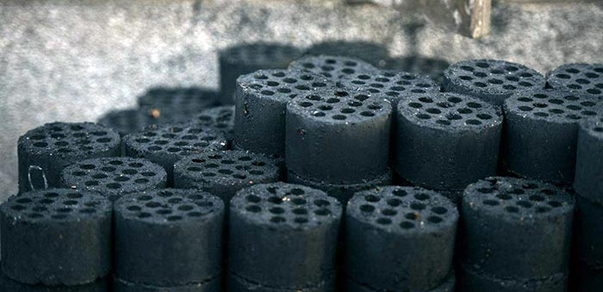
Figure 1 Image of briquettes with different mixing ratio of EFB and PE plastics

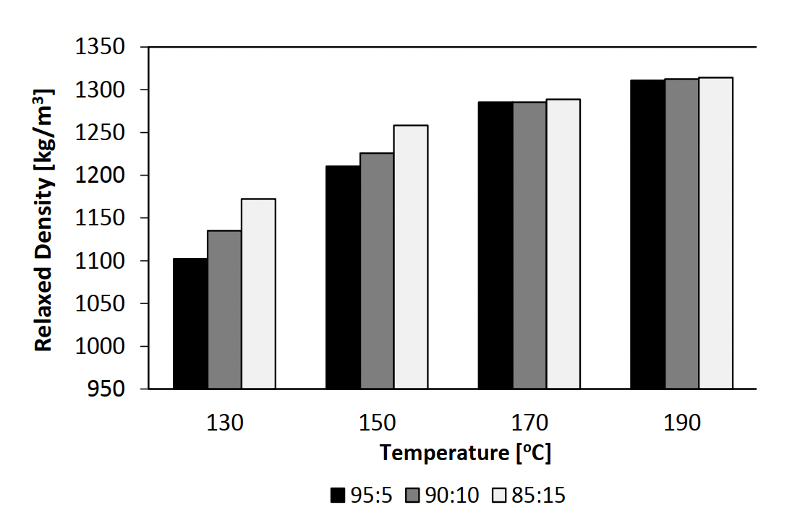
Figure 2 Relaxed density of briquettes with different mixing
ratio (EFB:PE), for various heating temperatures

Combustion Properties of Briquettes
Figure 6 shows gross calorific values of briquettes with different composition of pulverized EFB and shredded PE plastics, produced under various heating temperatures. Here, a red dashed line which represents the minimum requirement for commercialization as stated by standard DIN51731 is also created in the figure. DIN 51731 stated that the calorific values of the briquettes produced should be higher than 17500 kJ/kg. Based on Table 1, it can be said that the range of calorific values for briquettes in the present study complies with the requirement stated by DIN 51731. Overall, the gross calorific values are within the range of 17900 kJ/kg to 21000 kJ/kg. Equation (1) shows the calculation used for the calorific values.

XXXXXXXX Equation (1)

Properties of Briquettes 1
For proximate analysis, the results of moisture content and ash content are presented and discussed. Figure 7 shows moisture content of the briquettes with different mixing ratios that produced under various heating temperatures. Here, a red dashed line created in the figure represents a limitation of moisture content for commercial purposes as stated by standard DIN51731 (<10%). Based on the figure, it can be said that all values of moisture content (7% to 9%) fulfil the requirement as stated by the standard (<10%). Within the temperature range of the present study, the dependence of moisture content on heating temperature also could not be clearly observed.

Table 1 Standards used for proximate analysis
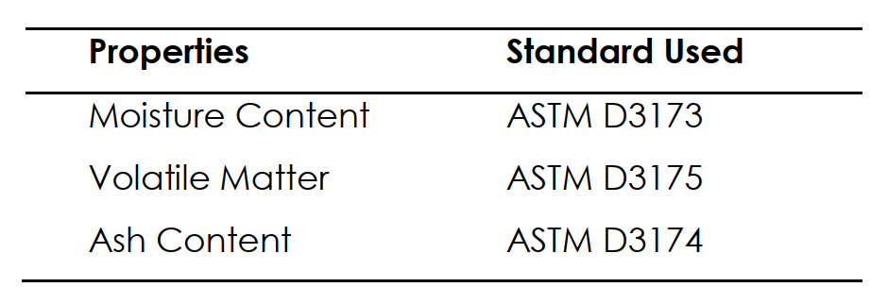

CONCLUSION

The briquettes with different mixing ratios of pulverized EFB and PE plastics were successfully developed, under various heating temperatures. Generally, it can be said that within the temperature range used in the present study, heating temperature plays a significant role in affecting physical properties such as relaxed density and compressive strength. Meanwhile, the mixing ratio of EFB and PE plastics does affect relaxed density and gross calorific value. It was found that all values of gross calorific value and moisture content fulfill the requirement as stated by DIN51731, regardless of mixing ratio and heating temperature. Meanwhile, the ash content is considered very competitive if compared to that which belongs to commonly used local briquette that contain mesocarp fibre and shell.

Acknowledgement
The authors acknowledge the Ministry of Education Malaysia and Universiti Teknologi Malaysia for giving cooperation and full of support in this research activity. The authors wish to thank the Research Management Center (RMC) for the Tier 2 Encouragement Grant (Q.J130000.2624.11J17) from the Ministry of Education Malaysia and Universiti Teknologi Malaysia. The authors also acknowledge Kilang Sawit Felda Lok Heng, Kota Tinggi, Johor for giving its full cooperation in this research by supplying the raw materials (EFB fibres).

Conflicts of Interest
The author declares that there is no conflict of interest regarding the publication of this paper.

AI Disclosure Statement
In this research, AI was used sparingly for language editing and to create conceptual illustrations in Figure 1. All images were reviewed, verified, and modified by the author to align with the research's scientific objectives. AI was not used to generate data, perform analysis, interpret results, or draw conclusions. All scientific content and responsibility remain solely with the author (Example only).

References (*APA style)
Economic Planning Unit, E. P. U. (2010). Tenth Malaysia Plan 2011-2015, Chapter 6-Building an Environment that Enhances Quality of Life. Retrieved May, 4, 2016.
Faizal, H. M., Latiff, Z. A., Wahid, M. A., & Darus, A. N. (2010, August). Physical and combustion characteristics of biomass residues from palm oil mills. In The 8th WSEAS International Conference on Heat Transfer, Thermal Engineering and Environment (HTE’10) Taipei, Taiwan (p. 34e38).
Lee, K. M., Zanil, M. F., Chan, K. K., Chin, Z. P., Liu, Y. C., & Lim, S. (2020). Synergistic ultrasound-assisted organosolv pretreatment of oil palm empty fruit bunches for enhanced enzymatic saccharification: an optimization study using artificial neural networks. Biomass and Bioenergy, 139, 105621.

